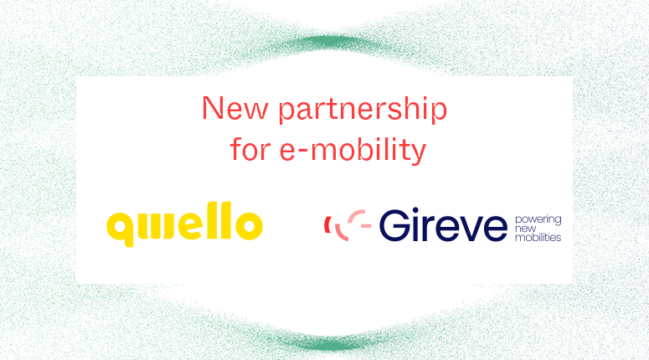

QWELLO partners with Gireve to accelerate its European expansion

Paris, 9th April, 2024 - The network operator continues its rapid development by integrating with Gireve’s roaming platform, thereby granting access to its charging stations for all EV drivers.
The leading-edge technology developer QWELLO has chosen Gireve to support and accelerate its European expansion. QWELLO currently manages an extensive network of charging stations in Sweden, Germany and Spain. Recent announcements have confirmed additional charging station installations in France, the UK, and more to come, underscoring QWELLO's dedication to enhancing the accessibility and user-friendliness of EV charging. 
QWELLO’s charging stations are designed to offer EV drivers a seamless charging experience on public spaces and municipalities. They provide power levels ranging from 11 to 22kW and are strategically located in public spaces and municipalities. This approach guarantees that EV drivers can readily locate and use these services while maintaining cost efficiency.
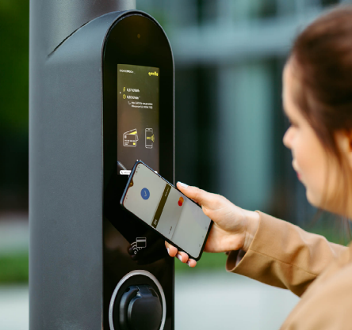
In line with its user-centric approach, QWELLO takes a further step by joining Gireve’s roaming platform. Through this partnership, QWELLO enables EV drivers to access its charging stations using their preferred mobile applications, simplifying the charging process, and enhancing convenience. This move aligns with Gireve's commitment to fostering collaboration and interoperability in the EV charging ecosystem.

Discover QWELLO’s offer on Gireve’s Connect Place: https://connect-place.gireve.com/en/marketplace/offer/show/47566?backTo=offer_index

Vincent Briola General Manager QWELLO France, expressed his enthusiasm for the new partnership: “We are proud to ​announce that we now have ​s​tarted operations in France, with live charging points in the southern and in the western parts of France. We have also recently won several public tenders with a significant number of charging points going live in the coming weeks and months, in all regions of France, with this solution​ that is already being enjoyed by other European cities such as Stockholm, Berlin, Frankfurt​, London, or the greater area of Madrid. Starting our new partnership with Gireve as the leading eMobility platform in France is a further step and ​a key element for us here in France. This will support the successful expansion of QWELLO’s unrivaled user-friendly charging-infrastructure solution, what is also tailor-made to match budget & regulation requirements of cities & municipalities”

To Félix Muhl, Business Development Manager at Gireve: ““QWELLO's decision to join forces with Gireve illustrates the growing significance of international interoperability in electric mobility. It reflects our shared commitment to make EV charging as user-friendly and accessible as possible. In this way, Gireve’s roaming platform is empowering charging point operators like QWELLO to open their networks to a broader international audience. We’re very excited to support QWELLO's expansion efforts. It allows us to increase our international presence, the goal being an enhanced charging experience for EV drivers across Europe."

The collaboration between QWELLO and Gireve promises to enhance the accessibility and convenience of charging for EV drivers. As the electric mobility landscape continues to evolve, collaborations like these will play a pivotal role in shaping the future of sustainable transportation.

About QWELLO
Qwello is a leading operator, owner and technology developer of charging stations for electric vehicles with representative offices throughout Europe. Qwello already operates charging infrastructure in several German and European cities and regions by entering into municipal partnerships through public concession contracts and providing both charging infrastructure and charging services. Qwello is growing rapidly and is headquartered in Munich, Germany. In doing so, Qwello has a clear commitment to the European market, highest ESG standards and a clear commitment to support decarbonization efforts in all forward-looking European societies.
www.qwello.eu/en
About Gireve
At the heart of electric mobility, Gireve connects stakeholders through its digital platform to enable contractual exchanges and EV roaming. Gireve processes and enriches data on charging points and driver behavior to provide analysis and advisory services. Electric mobility players turn to Gireve to get an overview of charging on a territory, develop a growth strategy in a new market, carry out the energy transition of their company, extend their services, or anticipate future issues. With its digital platform, Gireve references more than 470,000 charging points in 30+ European countries, operates more than 10,000 roaming contracts, and handles millions of transactions in its systems every year.
Learn more : www.gireve.com

Press contact QWELLO: Steve Kalthoff - ska@qwello.eu - +49 (170) 969 06 09 - ska@qwello.eu
Press contact Gireve: Marie Bonnefous - marie.bonnefous@gireve.com – 0033184732257

